SDLC Playbook

1. Discovery – Understanding & Aligning
1.1 The Learning Cycle – Lean Startup (Build → Measure → Learn)
The discovery phase is driven by the Lean Startup cycle loop:
- Build → Create hypothesis-driven increments (prototypes, MVPs)
- Measure → Capture user behavior and feedback
- Learn → Validate or pivot based on insights
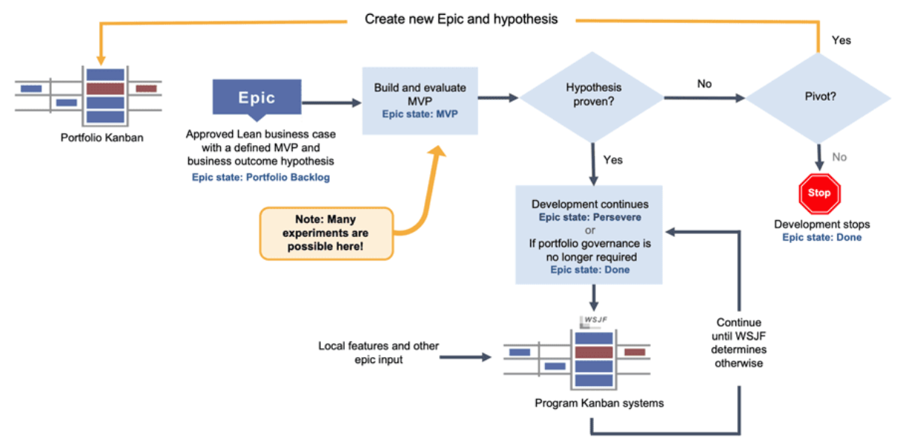

1.2 The North Star – Business level goal & Vision
Business level strategic goal
Product Vision
- Long-term aspirational goal aligned with business strategy
1.3 The Epics
Epics Classification
Functional Epics (Business Value) & Non-Functional Epics
- Summary
- Description
- Business Outcomes
- Acceptance Criteria
- Leading Indicators
- Non-Functional requirements

1.4 Ideation – Design Thinking
Design Thinking Stages
- Gemba / Interviews
- User persona
- Empathy → Understand user pain points
- Customer Journey
- Define Features →
- Architecture
Output: Customer centricity
- Customer problem
- Business impact
1.5 Setup Portfolio Kanban

1.6 Roadmap & Release Planning
- Align features across timeline.
- Prioritize(WSJF) based on:
  - Business value
  - Risk
  - Dependencies

1.7 Product Goals – MVP vs MMP
Type | Purpose
MVP (Minimum Viable Product) | Learning & validation
MMP (Minimum Marketable Product) | Market-ready value
Roadmap
- PI/Quarterly roadmap
- Solution roadmap timeframe – 2-3 years

2. Build & Test – Built-in Quality
Features
- Summary
- Description
- Benefit Hypothesis
- Acceptance criteria
Story
- Summary
- Acceptance criteria
2.1 Development Excellence
Ways of working
- Backlog refinement
- UI/UX practices
- Planning
- Unit testing test cases (TDD)
- Technical blueprint
- Implementation
- Pull Request
- Code review
- Version control
- Testing
- Deploy to Dev environment
2.2 CI Pipeline Mechanics
Flow
- Code commits to version control (Git)
- Automated build trigger
- Unit tests execution
- Static code analysis
- Artifact creation

Automation Stack (Illustrative)
- Version Control: GitHub / GitLab
- Build: Maven / Gradle
- CI Tools: Jenkins / GitHub Actions
2.3 Security as Non-Functional Requirement
Security is embedded, not added later.
Security Practices
- Static Application Security Testing (SAST)
- Dependency scanning
- Secrets management
NFR Acceptance Criteria Example
- No critical vulnerabilities (CVSS > 7)
- No hardcoded secrets
- Compliance checks passed
3. Continuous Deployment (CD) – Validating & Staging

3.1 Deployment Flow
- Promote builds from:
  - Dev → QA → Staging → Production
- Infrastructure as Code (IaC) used for consistency.

3.2 Advanced Validation (Non-Functional Testing)
Types of Testing
- Performance Testing
- Load Testing
- Stress Testing
- Security Testing (DAST)

3.3 Verification Before Release
- Validate deployment health:
  - Logs
  - Metrics
  - Alerts
Observability Stack
- Monitoring: Prometheus
- Logging: ELK Stack
- Tracing: Jaeger
4. Release on Demand (RoD) – Delivering Value
4.1 Strategic Release
Decouple:
- Deployment (technical) from
- Release (business decision)

Release Strategies
- Feature toggles
- A/B testing
- Phased rollout.

4.2 Stability & Enduring Value
Post-Release Activities
- Monitoring SLAs/SLOs
- Incident management
- Continuous patching

4.3 Closing the Loop – Feedback to CE
- Data collected feeds next cycle.
Metrics
- User engagement
- Conversion rate
- Performance metrics
Feedback Loop
Stage | Input to Next CE
Measure | Real usage data
Learn | Insights, improvements
Hypothesize | New ideas

5 Cross-Cutting Principles
5.1. Automation First Mindset
- Eliminate manual approvals where possible.
- CI/CD pipelines fully automated
- Self-service environments

5.2 DevSecOps Culture
- Shared ownership (Dev + Ops + Security)
- Security as code
- Compliance automated

5.3 Flow Efficiency
- Reduce batch sizes.
- Minimize waiting states
- Optimize lead time

5.4 Built-in Quality
- Quality gates at every stage
- No defect carry-forward

Final Summary
This playbook ensures:
- Fast feedback loops via Discovery
- High-quality builds via Continuous Integration
- Reliable deployments via Continuous Deployment
- Business Agility via Release on Demand
All aligned to Lean-Agile principles, with security and automation embedded throughout.

